

**YEAR 12 MATHEMATICS METHODS Test 3 2016**

**Logarithms**

## NAME: _________________________________________ Date: Wednesday 29 June 2016

**TEACHER: ____________________________**

|  |  |  |
| --- | --- | --- |
| **Calculator section:** | **15 minutes (max)** | **11 marks** |
| **Non-Calculator section:** |  | **34 marks** |
| **OVERALL:** | **45 minutes** | **45 marks** |

**INSTRUCTIONS:**

**Show FULL working Answer all questions on this test paper**

Questions or parts of questions worth more than two marks require working to be shown to receive full marks.

**Allowed: Maths Methods WACE formula sheets, 3 calculators, 1 A4 page of notes**

**Question 1 [3 + 2 = 5 marks]**

a. Accurately plot the graph $y=\log\left(x-3\right)$ on the axes below, clearly detailing the coordinates of any axis intercepts and the equations of any asymptotes.

b. The equation for the function shown below is $y=a×log\left(x+b\right)$

What are the values of *a* and *b* ?

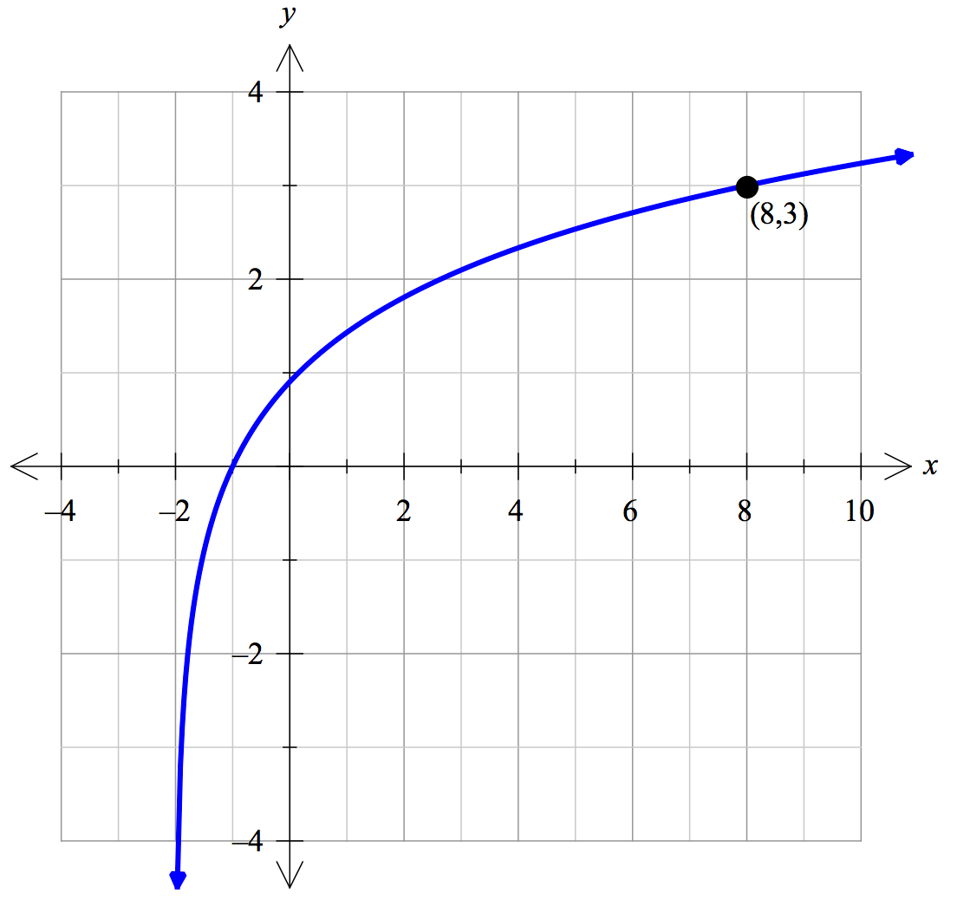

**Question 2 [2 + 2 + 2 = 6 marks]**

The intensity of sound is measured in decibels. As a consequence of the sensitivity of the human ear, this scale is logarithmic, which allows sound intensities across a wide spectrum (from almost inaudible to ear-splittingly loud). Decibels are measured using the equation below:

$$D=10\log\left(\frac{I}{I_{n}}\right)$$

where *D* = Decibel level (dB)

*I* = Intensity of sound in watts per square metre (W/m2)

*In* = W/m2 (this is the intensity of the least audible sound a human can hear)

a. Calculate the decibel level for

(i) normal conversation, which has a sound intensity of *I* = W/m2.

(ii) the kerb-side of a busy road, with a sound intensity of *I* = W/m2.

b. Calculate the sound intensity (*I*) that corresponds to the pain threshold of 125 dB.

c. Represent the above three points on the logarithmic graph paper, using them to plot the relationship between I and D

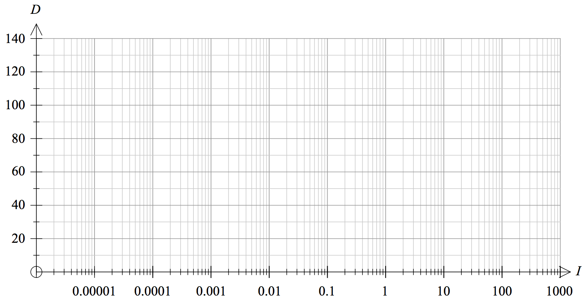

**End of calculator section – go back and check your working**

**Raise your hand when you are ready to go to the non-calculator section**

**At this stage you may work on both papers (without a calculator or notes)**



**YEAR 12 MATHEMATICS METHODS Test 3 2016**

**Logarithms**

## NAME: _________________________________________ Date: Wednesday 29 June 2016

**TEACHER: ____________________________**

|  |  |  |
| --- | --- | --- |
| **Calculator section:** | **15 minutes (max)** | **11 marks** |
| **Non-Calculator section:** |  | **34 marks** |
| **OVERALL:** | **45 minutes** | **45 marks** |

**INSTRUCTIONS:**

**Show FULL working Answer all questions on this test paper**

Questions or parts of questions worth more than two marks require working to be shown to receive full marks.

**Allowed: Maths Methods WACE formula sheets, 1 A4 page of notes**

**Question 3 [2 marks]**

a. Write $\log_{2}{64}=6$ as an exponential statement:

b. Write $3^{x}=7$ as a logarithmic statement:

**Question 4 [1 + 1 + 2 + 1 = 5 marks]**

Evaluate the following:

a. $\log_{2}{32}$ b. $\log_{3}{\frac{1}{9}}$

c. $5+3 ln{e^{2}}$ d. $3^{\log_{3}{5}}$

**Question 5 [2 + 2 = 4 marks]**

Express each of the following as a single logarithm:

a. $4\log{a}-2\log{b}+\log{c^{3}}$

b. $\log_{7}{xy}-2+\log_{7}{10}$

**Question 6 [2 + 3 + 4 = 9 marks]**

Solve using your knowledge of logarithms, giving solutions as exact values in simplest form.

a. $2\left(5^{x}\right)=12$

b. $3^{x+1}=4^{2x}$

c. $e^{2x}-5\left(e^{x}\right)=14$

**Question 7 [3 + 4 = 7 marks]**

a. Calculate $\frac{d}{dx}$ for the following:

(i) $\ln\left(3-4x\right)$ (ii) $\ln\left(\sqrt{2x^{3}+1}\right)$

b. Evaluate the following integrals:

(i) $\int{\frac{12x^{2}}{7-x^{3}}dx}$ (ii) $\int{2\tan\left(4x+1\right)dx}$

**Question 8 [4 + 3 = 7 marks]**

a. Calculate the equation of the tangent to the curve $y=\ln{x}$ at the point $\left(e^{2},2\right)$.

b. Evaluate the area contained between the function $y=\frac{4}{x}$ and the *x*-axis from an *x*-value of *e* to an *x*-value of *e*3.

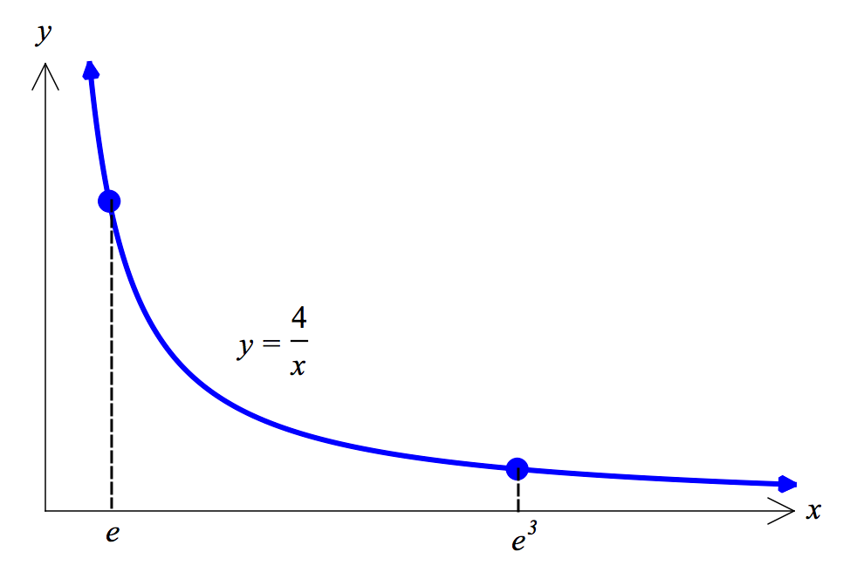

**End of non-calculator section – go back and check your working**